Helmet Detection and License Plate Recognition

Jyothika, Jyothi Shankar Swarup, Monith Chaitanya Varma, Raja Venkata Gunneswara Gupta

**Under the guidance of** Dr. N Thirupathi Rao (Assistant Professor)

*Department of Computer Science and Engineering, Vignan’s Institute of Information Technology, Jawaharlal Nehru Technological University, Kakinada*

# Abstract

deep learning approach Road collisions and deaths have shot up disproportionately as motorization has grown more prevalent This study points to A means of communication to locate helmets and license plates using object detection models based on. Riders of motorbikes should put on helmets to stay out of incidents such as these. To monitor and swear to the safety of motorcycle passengers by suing their for not wearing helmets, we need a substantial traffic police force. This project utilizes YOLOv3 to locate things at three levels using deep learning, enabling helmet detection at stage two and license plate detection at level three. Whenever a license plate appears, an OCR technology uses it to extract the digits using a cropped image of the plate. Our equipment for retrieving registration plates and identifying helmets have been created utilizing the methods mentioned above.

***Key Words:*** *YOLO, Neural Network, OpenCV, Video Detection, OCR, Tracking object, etc*

# Introduction

The strategy addressed in the present piece automates the operation of casting a watch on motorcyclists through finding those that are not wearing helmets and retrieving their motorcycle's registration number in real time from surveillance footage at crossroads. The challenging portion of a computer vision framework is tracking an object as it is covered up by other items, and this is here identification and tracking comes in action.

The key components of Helmet Detection include:

1. **OpenCV:** It is a prominent open-source library for image processing, computer vision, and machine learning can is employed for identifying things, individuals, and written materials**.**
2. **YOLO:** The algorithm that uses convolutionalneural networks to detect and recognize objectsin real-time. It is important for its speed, accuracy, and learning capabilities.
3. **TensorFlow:** It offers the multiple levels of abstraction, Keras API, eager execution, and Distribution Strategy API for large ML training task.
4. **Optical Character Recognition (OCR):** The procedure of transforming images of written, printed, or handwritten text into device-encoded text is referred to as optical character recognition (OCR). Acquiring information, performing basic processing, and categorizing and separating characteristics are the three basic stages. Pattern recognition and feature detection are the two fundamental methods of extracting features in OCR. By attempting to identify white pixel rows with black pixels in between, OCR involves identifying every single character. A neural network undergoes training to generate a generalized device>text translation. into the subsequent workshops. It may be critical to evaluate the data quality and boost the data even more. There are free online OCR libraries, like the Tesseract library, which can be leveraged to boost efficiency.

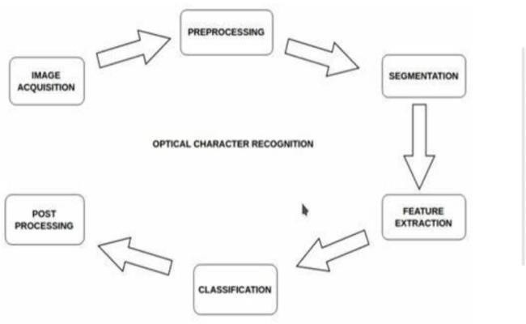

1. **Object Dectection:** CCTV cameras present at traffic signals should detect helmet, and if anyperson found without helmet is checked into the database of RTO, a mail should be sent to him/herregarding fine.to prove the concept, a prototype model will be developed using laptop wed cam and a window based application.to detect and recognisenumber, a standard indian number plate image willbe uploaded.

# Literacture Review

Accidents occur when individuals fail to don the safety helmet, regardless the fact that it has been shown to be an effective protective device in many manufacturing sites. The techniques employed for recognizing helmet wearers are the goal identification algorithm, R-CNN, SSD, YOLO, and YOLO. Contrasting the YOLO algorithm to the R-CNN algorithm, the first achieves real-time detection speed but not precision. With the goal to enhance reliability yet preserve the speed benefit, especially for the recognition of small items, Silva et al. indicated YOLOv2. Target identification techniques based on deep learning have benefited significantly in recent years, allowing for one- and two-stage detection algorithms with and without region suggestion. The feature map's altitude and breadth have been decreased by half, and its number of streams is doubled after traversing the pooling layer in YOLOv2's Darknet-19 backbone network, which is based on the VGG16 model design method. The output feature map size can be restricted by the step size, and the feature extraction network used is Darknet53, with just a single convolutional layer.

# Problem Statement

Bikers are increasing, leading to road mishapes and deaths due to negligence and lack of medicalattention.

# Scope of the Proposed Work

In this case study, the number plate of a two-wheeler rider who is not wearing a helmet is obtained employing a YOLO CNN model.

# Proposed System

For the reason of recognizing helmets and registration numbers, the proposed method will employ methods involving computer vision and deep learning methods. For feature extraction and classification, it will employ the use of convolutional neural networks equipment (CNNs), face detection algorithms for helmet detection, object detection strategies for license plate detection, and Tailwind CSS for fashion. Users will be capable to upload videos, pictures, and live video streams by means of the system's connection with a Flask website. The output of the system willbe displayed in real-time on the website. Our presented feature extraction procedures made recourse to hybrid descriptors based on LBP, HOG, and Hough twists. Different types of objects, namely automobiles, motorcyclists, pedestrians, and workers, can be recognized utilizing either YOLOv2 and COCOdatasets. circles and equipment-based Fourier transform is utilized for distinguishing safety helmets, and HOG descriptors can be used to detect helmet additionally. Effective helmet classification has been achieved employing GLCM statistical features and a back-propagation artificial neural network. Methods used in the helmet detection system comprise combining the dataset, moving object detection, background subtraction, object classification using neural networks, and license plate number extraction.

# Related Work:

Due to the evolving recognition of objects algorithms' better precision and quicker detection durations in the more recent versions, the research projects within the object detection region have grown more frequent. To understand how algorithms have changed over time, what they can do, the technical obstacles faced all through the project's development, and how to overcome those obstacles, it is important to examine prior studies in the area. SSD, MobileNet, Faster R-CNN, Inception, and YOLO are object recognition approaches that are suitable for this application. Considering the internals of various algorithms, the positive aspects and downsides of picking the algorithm that's appropriate for this application. The examination of the discussed aspects of each algorithm will be the primary focal point of this review of the previous work, and our choice of an algorithm in particular for this project will be justified. Systematic observations and secondary analysis of trauma registries were used to gauge the helmet wear among motorcycle riders and passengers in Thika and Naivasha. With top-1 and top-5 error rates of 37.5% and 17.0%, respectively, 1.2 million high-resolution photos were broken down into 1000 classes using an enormous deep convolutional neural network.

# Existing Model

The present setup mainly utilizes CCTV documentation to monitor crashes, allowing traffic police to zoom in on the license plate in to determine where the rider is not wearing a helmet to peer into the frame where the violation has taken effect. But considering that there are so numerous accidents and more motorcycles on the road every single day, this involves a lot of effort and time. What if there were a system who would monitor for traffic infractions like riding a motorcycle or moped wearing a helmet and, if observed, would automatically extract the license plate number of the accused car. Recent investigations have successfully finished this work integrating characteristics derived from CNN, R-CNN, LBP, HoG, HaaR, etc. But such attempts have restrictions in relation to efficacy, preciseness, and the manner in which rapidly items can get recognized and categorised. in this research the undertaking, a non-helmet rider detection system is developed in an attempt to automatically carry out the detection of the traffic violation of not wearing a helmet and the gathering of the license plate number of the vehicle.

# Methodology

Real-time identification of objects and recognition methodology leveraging the You Only Look Once (YOLO) model based on DNN is 1000 times more quickly than R-CNN and 100 times faster than Fast R-CNN.Custom Object identification is the art of finding instances of a specific class in images and videos. Three components needed to be established for the purpose to recover the helmet and license plate number. Weiner filtering, anticipate enhancement, YOLO V2 for ROI, and CNN for Optical Character Reader are employed in the implementation of the proposed endeavor. To be able to estimate the total number of boundary boxes (which are additionally referred to as anchor boxes) that will surround products that perform well in the developed classes, the YOLOv2 algorithm partitions the picture into a grid. Boundary box. The dimensions of the ground truth boxes from the original dataset have been organized for determining the most prevalent sizes and shapes for boundary boxes. The image is divided into a S S grid and the question detection problem is addressed as a regression problem. A bounding box, confidence, and class probability map will be constructed for each grid.

# Helmet Detection and Number Plate Dectection

YOLOv2 is a custom object detection algorithmused to train for specific classes. It is trained using YOLO's custom weights and includes significant design enhancements. Darknet-53 is wholly convolutional and has a more complicated structure than other feature networks. Yolo is a speedy object detection methodology that uses 53 convolutional layers and a batch equalization layer with a Leaky RELU activation function. class labels additionally indicate the location of every single object in the image. The Yolo methodology breaks a picture into many different areas to determine a Region of Interest using a matrix-based algorithmic structure. (ROI). To simply include the most likely ROI in the filter, the threshold value is fixed at 0.94.

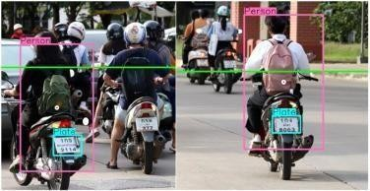

# License Plate Recognition

Convolution neural networks (CNNs) are the ultimate consequence of this convolution process, during which multiple characteristics are gathered from different parts of the image. Depending on where every patch can be seen in the image, each convolution layer's output is used for creating a new 2-Dimensional array. Convolutional neural networks use the response improvement technology referred to as pooling to streamline huge visuals while preserving the important information. If a number that is negative appears, replace it with zero (0). By preventing established standards from getting just short of 0 or exploding all the way to infinity,

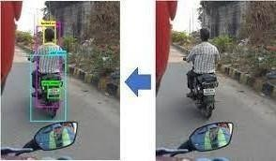this keeps CNN scientifically healthy. Background addition, they can the SMO classifier, and CNN have all been recommended as deep learning techniques for recognising motorcycles in videos.

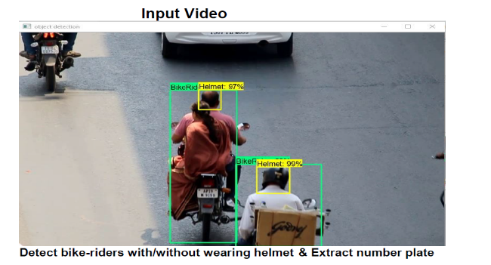

# System Architecture

The picture pre-processing, image feature extraction, image classification, and result detection processes are the crucial details. Greyscale conversion, noise removal, and pixel extraction constitute each component of image pre-processing. Using tiny squares of input data, envision feature extraction involves learning image features. In classification, features have been divided into contaminated and safe categories. The outputs have been categorized in the result detection step using the softmax or sigmoid activation functions. Any server running Flask can be used to deploy the system, and any accessible via the internet device can access it. The suggested algorithm reduced subdivisions to 16 and fixed filter size to 18, effectively identifying the ROI required to perform image enhancement.

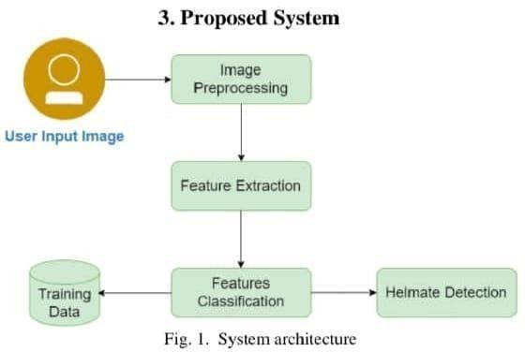

To determine the driver's license plate and detecting the helmet. There are actually five steps in this whole process. The motorcyclist's picture is initially included for the intent of helmet detection, and then the background will be eliminated from the video throughout processing. The segmentation of two-wheelers goes in third. The software then checks for individuals who have not donned helmets. The final step involves determining the sticker on the vehicle and displaying the number from the image. This model tells us that since the motorcycles are affordable, people use it for daily transportation. Due to this increased use the occurance of accidents are high. As many cities have cameras in place for reasons of security, we may utilize those for recognizing non-helmet riders, which would be a feasible and affordable solution. The above technique relies on the use of the CNN (Convolution Neural Network), a machine learning tool, which produces beautiful pictures irrespective many problems like the lighting, variations in the environment, etc.

START

Take Video as input

Read Frame

NO

NO

Detect bike

Detect Person head

NO

Detect helmet

YES

Detect number plate

Extract number palte text

STOP

# Module

Pre-processing is the process of strengthening or minimizing unfavorable irregularities in images to get ready for additional processing. A supervised machine learning technique involves classification.

# Design

The first stages in the software engineering process are software design, which serves as only way to faithfully translate what the client wants into an executed software product or system. Architecture model, data structure design, interface design, and procedural design comprise all four of its parts. Design is crucial for software quality due to the fact that it produces presentation of the software that can be checked for condition. We stand into the risk of establishing an unstable system without an established design.

# Result

**After Uploaded the Image**

after getting the input photographs from the surveillance tape.the CNN algorithm is used to locate the people within the image who are not wearing safety helmets, and outcomes are displayed as a number plate and the license number for those who were identified. their driving license number is shown here in a red box.

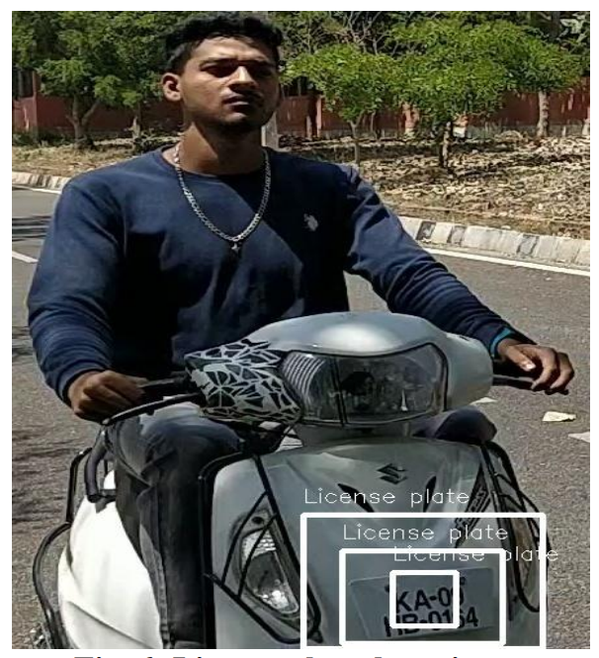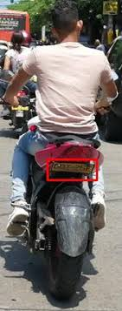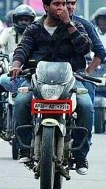

# 2.After Uploaded the Videos

Here, there are videos who were recorded from CCTV footage.CNN algorithm is used for identifying photos, and in these uploaded videos the algorithms used recognize each frame in the video and take the frame where the two- wheelers are not wearing helmets, restoring the output of the licenses number for each of the two-wheelers in the video who are not wearing helmets. following this procedure, the all the permission numbers to earn those who were two-wheelers are displayed in the red box who are not wearing helmets.

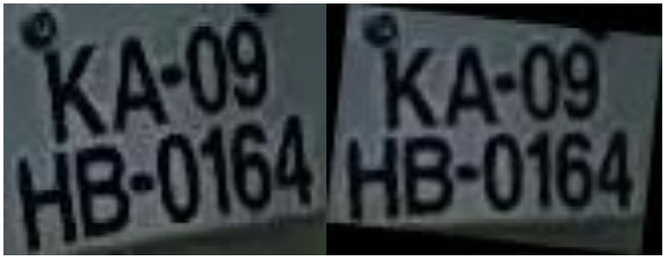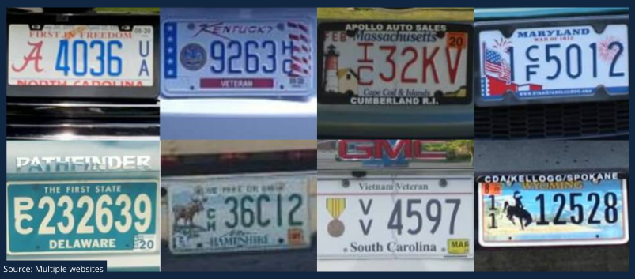

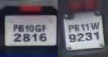

# Conclusion and Future Work

In this research paper, we present the incorporation of a helmet and registration plate detection system into a Flask website. For object detection, the system leverages a deep learning model based on the YOLO approach. That was designed to be simple to deploy and utilize. The website's design is simple and responsive because of the Tailwind CSS styling. The equipment could be modified according to individual branding demands and achieves superior precision when recognizing helmets and licences plates in photographs, videos, and live streaming data. The system can also be employed for monitoring traffic, road safety, and law enforcement. The system that was recently put in place is a prototype that, with approval from the right people, can be expanded to process regular traffic video. A big database is set up for maintaining track of violators and their challan payment history, and a high-resolution camera is advised to maintain precision and accuracy.

# References

[1]. J. Chiverton, “Helmet Presence Classification with Motorcycle Detection and Tracking”, IET Intelligent Transport Systems ,Vol. 6, Issue 3, pp. 259–269, March 2012.

[2].rattapoom Waranusast, Nannaphat Bundon, Vasan Timtong and Chainarong Tangnoi, “Machine Visiontechniques for Motorcycle Safety Helmet Detection”, 28th International Conference on Image and Vision Computing New Zealand, pp 35-40, IVCNZ 2013.

[3]. Romuere ilva, Kelson Aires, Thiago antos, Kalyf A dala, Rodrigo Veras, Andr e oares, “Automatic Detection Of Motorcyclists without Helmet”, 2013 XXXIX Latin America Computing Conference (CLEI). IEEE, 2013.

[4]. Romuere ilva, “Helmet Detection on Motorcyclists Using Image Descriptors and Classifiers”, 27th IBGRAPI Conference on Graphics, Patterns and Images.IEEE, 2014.

[5]. Thepnimit Marayatr, Pinit Kumhom, “Motorcyclist‟s Helmet Wearing Detection Using Image Processing”, Advanced Materials Research Vol 931- 932, pp. 588-592, May-2014.

[6]. Amir Mukhtar, Tong Boon Tang, “Vision Based Motorcycle Detection using HOG features”, IEEE International Conference on Signal and Image Processing Applications (ICSIPA) IEEE, 2015.

[7]. Abu H. M. Rubaiyat, Tanjin T. Toma, Masoumeh Kalantari-Khandani, “Automatic Detection of Helmet Uses for Construction afety”, IEEE/WIC/ACM International Conference on Web Intelligence Workshops (WIW). IEEE, 2016.

[8]. XINHUA JIANG “A tudy of Low-resolution Safety Helmet Image Recognition Combining Statistical Featureswith

Artificial Neural Network”. IN: 1473-804x

[9]. Kunal Dahiya, Dinesh ingh, C. Krishna Mohan, “Automatic Detection of Bike-riders without Helmet using Surveillance Videos in Real-time”, International joint conference on neural network (IJCNN). IEEE, 2016.